**Latest Reviews on Nintendo:**

1. Detective Pikachu Returns Review (Oct 5, 2023)

Carli Velocci from IGN:

* When Detective Pikachu hit the 3DS in 2016, we'd never seen anything quite like it in the vast collection of Pokemon games. Its casual whodunit's story was an easy solve but it was cute colorful and most importantly different and yet now that Detective Pikachu and his tiny herringbone hat have returned with a cup of coffee in hand it doesn't feel as exciting. In fact, it feels like one step backwards. It is still a pleasing colorful sweet adventure and the story comes to a mostly satisfying conclusion of the Detective Pikachu Saga, but its greatest mystery is what went on behind the scenes that resulted in some of these baffling decisions in the story and mechanics.

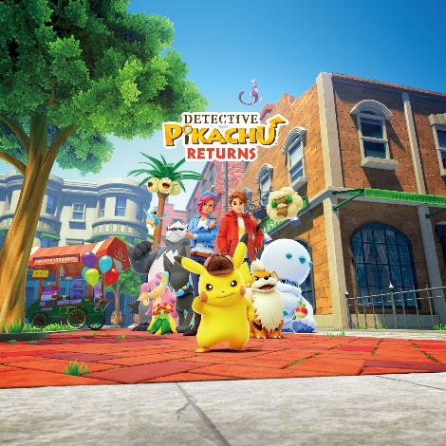

https://m.media-amazon.com/images/M/MV5BNjY2ZWQ2OWItN2U3My00MDkyLTllMjUtNmRlMjJmNDQ1YmU0XkEyXkFqcGdeQXVyMTk2OTAzNTI@._V1_.jpg

1. EA Sports FC 24 for Switch Review (Oct 5, 2023)

Andrew McMahon from IGN:

* It's that time of year once again time to see if the Nintendo Switch version of EA's Premier Soccer series is still a complete mess. The good news is that alongside a name change to EA Sports FC 24, the game formerly known as FIFA has finally moved past the point where its switch port is simply a copy of the previous year. The bad news is that it is still dreadfully out of date and some modes barely work. The switch version of FC 24's long overdue upgrade to the frostbite engine is a considerable step up from the previous Legacy engine. Visuals look a bit more detailed and the gameplay feels better than FIFA 23 leg Legacy Edition.



https://static.standard.co.uk/2023/07/18/16/EA_Sports_FC24_main.jpg?width=1200&height=1200&fit=crop

1. Cocoon Review (Sept 29, 2023)

Hana Kim from IGN:

* Without a single word, cocoon takes a small cicada-like creature on an exciting journey through the cosmos using only a thumb stick and a single button. Cocoon differentiates itself from those monumentally creepy side-scrolling adventures as a 3D puzzle platformer. The additional dimension provides a refreshing amount of well depth to its challenging and intriguing puzzles. These puzzles build on each other in smart ways keeping fundamental mechanics from the desert at the very start integrated and important all the way to the end. And even as cocoon gets more and more complex, its minimalist controls make sure it never feels overwhelming.

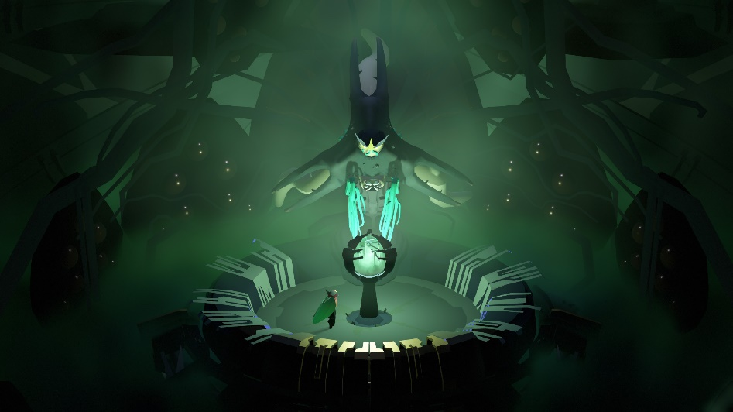

https://cdn.vox-cdn.com/uploads/chorus_image/image/72697647/cocoon_moth_boss_green_tower.0.jpg